ROLLBACK(descp)

Ex:

We deleted a particular row from the usa_states table

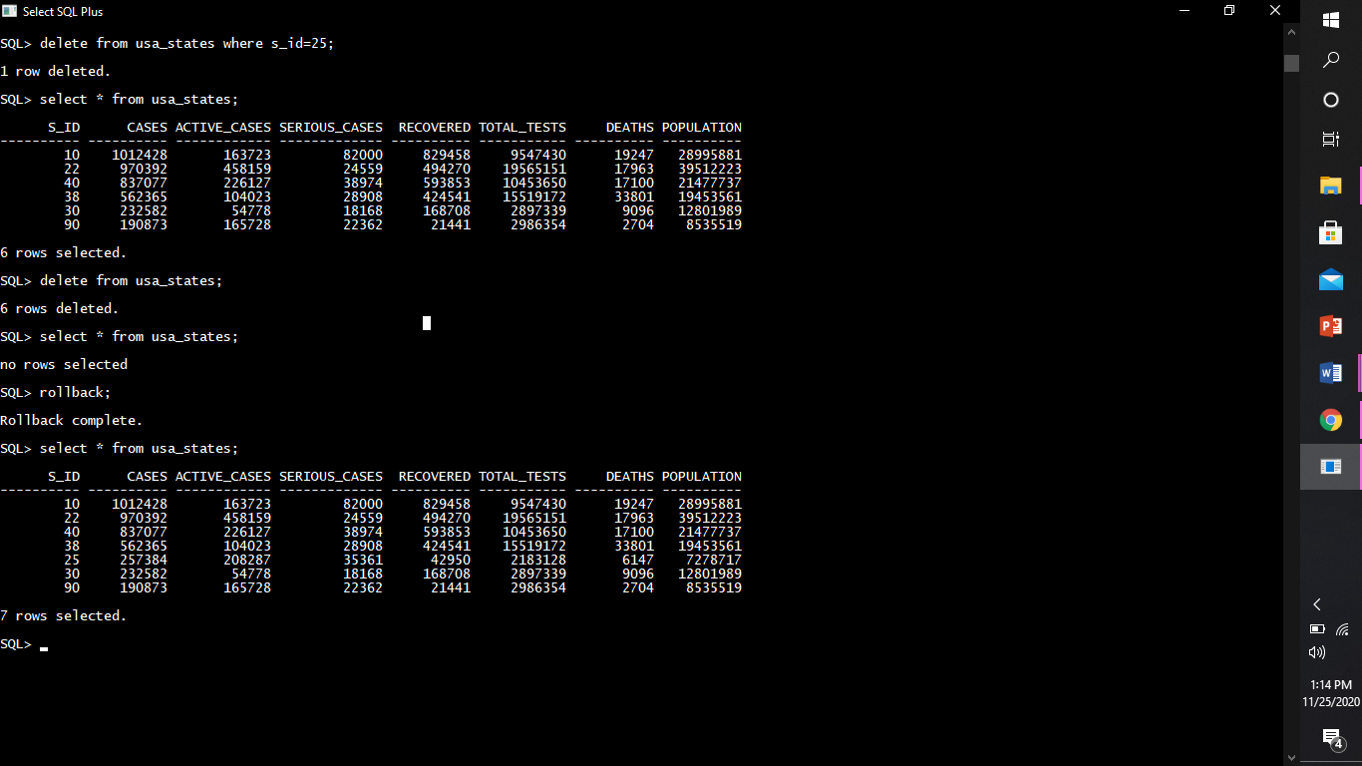

Then we deleted the whole usa_states table



Then we performed the rollback operation



And all the operations performed were rolbacked since it was dml commands

Rollback can’t be done on ddl commands.

Ex2:

We have a table as vaccine_creation_info

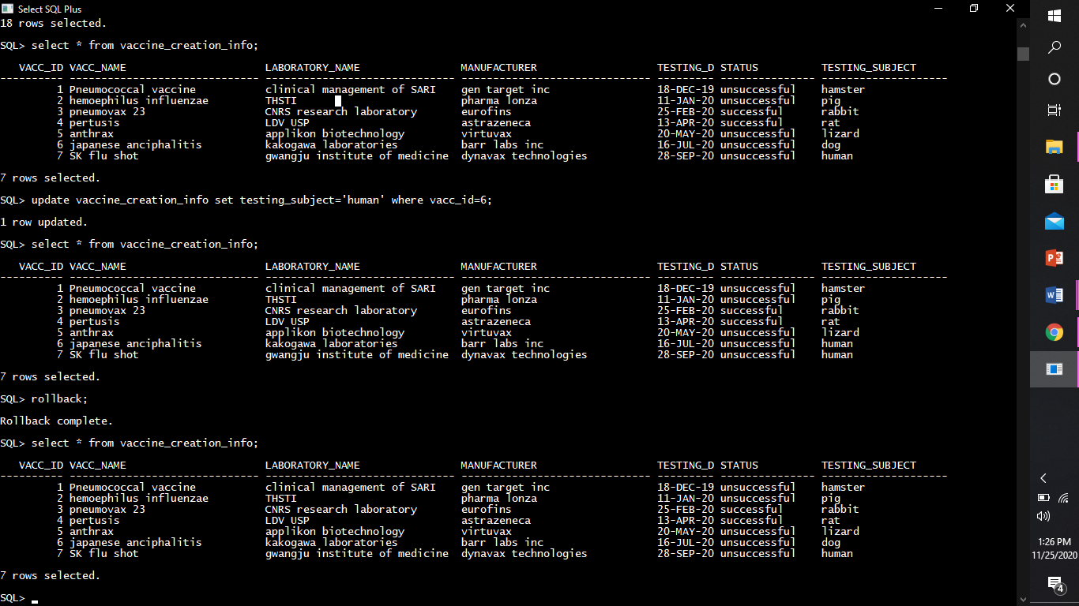

This table is updated using the update command



The updated command can be rollbackd since it’s a dml command

So after performing rollback



The updated row is rollbacked to it’s original value.

COMMIT(desc)

Used to commit the work done so far

Once commited cannot be rollbacked

SAVEPOINT

Savepoint baad me deti hu jagah chod dena bas.